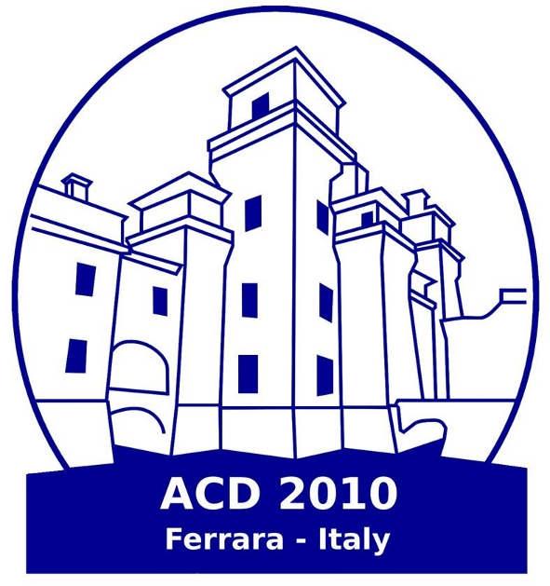

8th European Workshop on Advanced Control and Diagnosis, ACD 2010
18-19 November 2010, Ferrara, Italy

REGISTRATION FORM

- Please use one form per person
- Please fill out completely the form and return it by fax or e-mail to the Congress Secretariat at +39 0532 767347 or convegni@unife.it

IMPORTANT NOTE:
Deadline for registration is NOVEMBER 3rd, 2010

SCIENTIFIC CONTRIBUTION DETAILS

PAPER TITLE:°°°°
PAPER ID: °°°°

GENERAL INFORMATION
Personal information is required for the invoice, which we are obliged to provide after each payment.

TITLE:°°°°
FIRST NAME:°°°°
LAST NAME: °°°°
COMPANY OR ORGANIZATION: °°°°
GENDER: | MALE |  |  |  |  | FEMALE
  °
  °
DATE AND PLACE OF BIRTH:
FISCAL CODE (mandatory for Italian people): |  | ° | ° | ° | ° |  | ° | ° | ° |  | ° | ° | ° | ° | ° | ° | ° | ° | °
ADDRESS (please indicate your personal address of residence): °°°°

CITY/STATE: °°°° |  |  |  |  |  |  |  |  |  | ZIP/POSTAL CODE: °°°°
COUNTRY: °°°°
PHONE: °°°° |  |  |  |  |  |  |  |  |  | FAX: °°°°
E-MAIL ADDRESS: °°°°

REGISTRATION FEES

CHOICE | FEES | AMOUNT
°°°° | regular fee | 146 eur
°°°° | regular fee 200 eur + social dinner 54 eur | 200 eur
°°°° | student fee | 96 eur
°°°° | student fee 150 eur + social dinner 54 eur | 150 eur

Additional tickets for the Social Dinner can be booked here. The cost per ticket/person is 54,00 EUR (taxes 20% included) and shall be paid directly on site at the registration desk.

DO YOU WANT TO BOOK ADDITIONAL TICHETS? | YES | NO | Number of tickets
  °°
  °°
  °°
Accompanying person: °°°°

INVOICE DATA
In absence of FULL DATA REQUIRED, the invoice will be addressed to the ACD 2010 registrant.

DO YOU WANT TO INVOICE YOUR ORGANIZATION/INSTITUTION? |  | YES | NO
  °°
  °°
ORGANIZATION/ISTITUTION NAME: °°°°
ADDRESS OF THE ORGANIZATION/INSTITUTION: °°°°

CITY/STATE: °°°° | ZIP/POSTAL CODE: °°°°
COUNTRY: °°°°
FISCAL CODE OR VAT NUMBER (MANDATORY): °°°°

METHOD OF PAYMENT
Important note: payment must be made in Euros only. Registration must be accompanied by the full payment.

°  BANK TRANSFER |  | Please make drafts payable in Euro to:  Account Name: Consorzio Ferrara Ricerche  Bank Details: Unicredit Private Banking - Via Frizzi 21 - 44121 Ferrara, Italy  Account Number: 1326114  CIN: I - ABI: 03223 - CAB: 13000  IBAN: IT 13 I 03223 13000 000001326114  SWIFT/BIC: UNCRIT2T  - Please ensure the name of the congress (ACD 2010) and of the participant are stated on the bank transfer  - Bank charges are the responsability of the participant and should be paid at source in addition to the registration  - In order to receive the confirmation of the registration, please send to the Secretariat the remittance of the payment
CREDIT CARD: |  |  |  |  |  | MASTERCARD |  |  |  |  |  |  |  | VISA
  °
  °
  °
CARD NUMBER: |  | ° | ° | ° | ° |  | ° | ° |  | ° | ° |  | ° | ° | ° | ° | ° | ° | ° | °
EXPIRY DATE (MONTH/YEAR) |  |  | ° | ° | / |  | ° | °
SECURITY CODE: |  |  | ° | ° | °
CARDHOLDER: | First Name: °°°° |  |  |  |  |  |  |  |  |  |  | Last Name: °°°°
CARDHOLDER’S SIGNATURE  (I authorise to debit my credit card for the amount of EURO______) |  |  |  |  |  |  |  |  | °°°°

Your RECEIPT and CONFIRMATION LETTER will be sent by e-mail from the Secretariat once received the notification of the payment. Please note that your registration will only be valid when full payment is received by the Secretariat.

NOTE TO SECRETARIAT

REMARKS: | °°°°

PRIVACY NOTICE - Informational statement according to article 13 of Legislative Decree 196/2003
Information and personal data are collected through the voluntary compilation of the form and are used for the purpose of the participation at the Workshop. The data collected can be memorized both in electronic and paper format and will be used by us respecting all the measures provided by law for the safeguarding of the rights of the interested parties. The giving of data is optional; possible refusal to provide this data could mean the inability on our part to send the information requested and process your registration to the Workshop. Data will be used also with electronic devices and may be used for administrative, fiscal and/or commercial activity. We will not pas data to unauthorized third parties. Responsibility for the use of data is Consorzio Ferrara Ricerche, Via Saragat 1, 44122 Ferrara (FE). You should act for your right as stated in art. 7, by sending an e-mail to cfr@unife.it.

I have read and agree with the above statement (MANDATORY)
DATE: °°°° | SIGNATURE: °°°°

